GRAFO DE FLUJO

Login

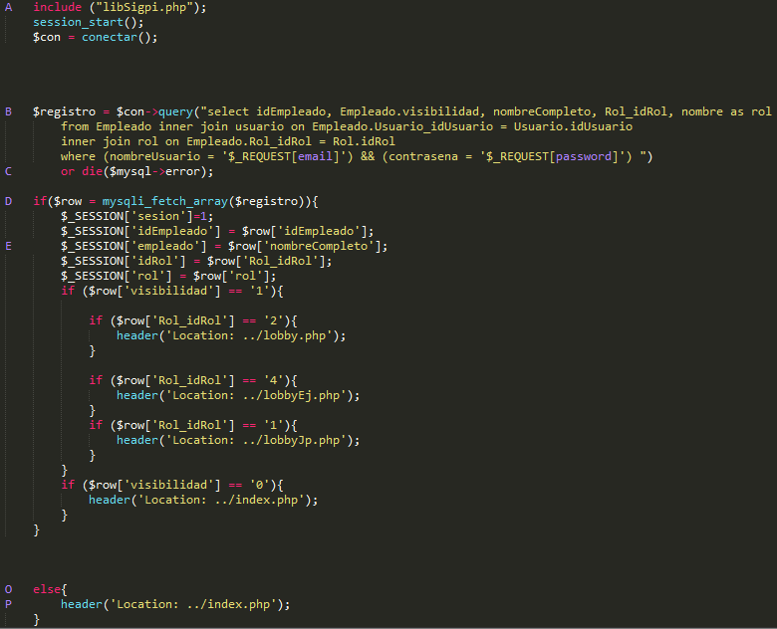

2

1

3

4

5

6

Complejidad ciclomatica:

V(G) = #Aristas - #Nodos + 2

V() = 6-7+2 = 3

|  |
| --- |
| Aristas |

|  |  |  |  |  |  |  |  |  |
| --- | --- | --- | --- | --- | --- | --- | --- | --- |
| Caminos | |  |  |  |  |  |  | | --- | --- | --- | --- | --- | --- | | 1 | 2 | 3 | 4 | 5 | 6 | | Casos de prueba |
| AC | |  |  |  |  |  |  | | --- | --- | --- | --- | --- | --- | | 0 | 1 | 0 | 0 | 0 | 0 | |  |
| ABDE | |  |  |  |  |  |  | | --- | --- | --- | --- | --- | --- | | 1 | 0 | 1 | 1 | 0 | 0 | |  |
| ABDOP | |  |  |  |  |  |  | | --- | --- | --- | --- | --- | --- | | 1 | 0 | 1 | 0 | 1 | 1 | |  |

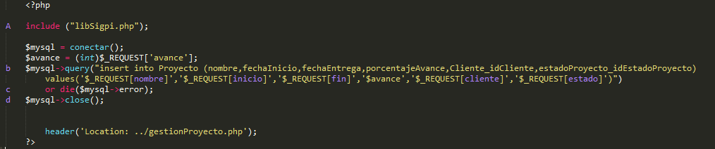nuevoProyecto

4

1

3

22

Complejidad ciclomatica:

V(G) = #Aristas - #Nodos + 2

V() = 4-4+2 = 2

|  |
| --- |
| Aristas |

|  |  |  |  |  |  |  |
| --- | --- | --- | --- | --- | --- | --- |
| Caminos | |  |  |  |  | | --- | --- | --- | --- | | 1 | 2 | 3 | 4 | | Casos de prueba |
| Abd | |  |  |  |  | | --- | --- | --- | --- | | 1 | 1 | 0 | 0 | |  |
| Acd | |  |  |  |  | | --- | --- | --- | --- | | 0 | 0 | 1 | 1 | |  |